**St. Xavier’s College**

**(Affiliated to Tribhuvan University)**

**Maitighar, Kathmandu**



**COMPUTER GRAPHICS**

**LAB ASSIGNMENT #1**

**TO DRAW THE GIVEN CHECKBOX**

**Submitted By**

Ronak Agrawal

013BSCCSIT033

**Submitted To**

|  |  |
| --- | --- |
| Er. Anil K Shah  Lecturer, St. Xavier’s College |  |

Department of Computer Science

Date of Submission: 04 Aug, 2015

**STATEMENT: WRITE A PROGRAM TO DRAW A CHECKBOX.**

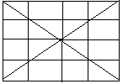

**Source code:**

//---------------------------------------------------------------------------

#include <vcl\vcl.h>

#pragma hdrstop

#include "Unit1.h"

//---------------------------------------------------------------------------

#pragma resource "*.dfm"

TForm1 *Form1;

//---------------------------------------------------------------------------

__fastcall TForm1::TForm1(TComponent* Owner)

: TForm(Owner)

{

}

//---------------------------------------------------------------------------

void __fastcall TForm1::Button1Click(TObject *Sender)

{

Form1->Canvas->Pen->Width=5;

Form1->Canvas->MoveTo(10,10);

Form1->Canvas->LineTo(200,10);

Form1->Canvas->MoveTo(10,10);

Form1->Canvas->LineTo(10,200);

Form1->Canvas->Pen->Width=1;

Form1->Canvas->LineTo(200,200);

Form1->Canvas->LineTo(10,10);

Form1->Canvas->MoveTo(200,200);

Form1->Canvas->LineTo(200,10);

Form1->Canvas->LineTo(10,200);

Form1->Canvas->MoveTo(105,10);

Form1->Canvas->LineTo(105,200);

Form1->Canvas->MoveTo(53,10);

Form1->Canvas->LineTo(53,200);

Form1->Canvas->MoveTo(153,10);

Form1->Canvas->LineTo(153,200);

Form1->Canvas->MoveTo(10,105);

Form1->Canvas->LineTo(200,105);

Form1->Canvas->MoveTo(10,55);

Form1->Canvas->LineTo(200,55);

Form1->Canvas->MoveTo(10,155);

Form1->Canvas->LineTo(200,155);

}

//---------------------------------------------------------------------------

**Output:**

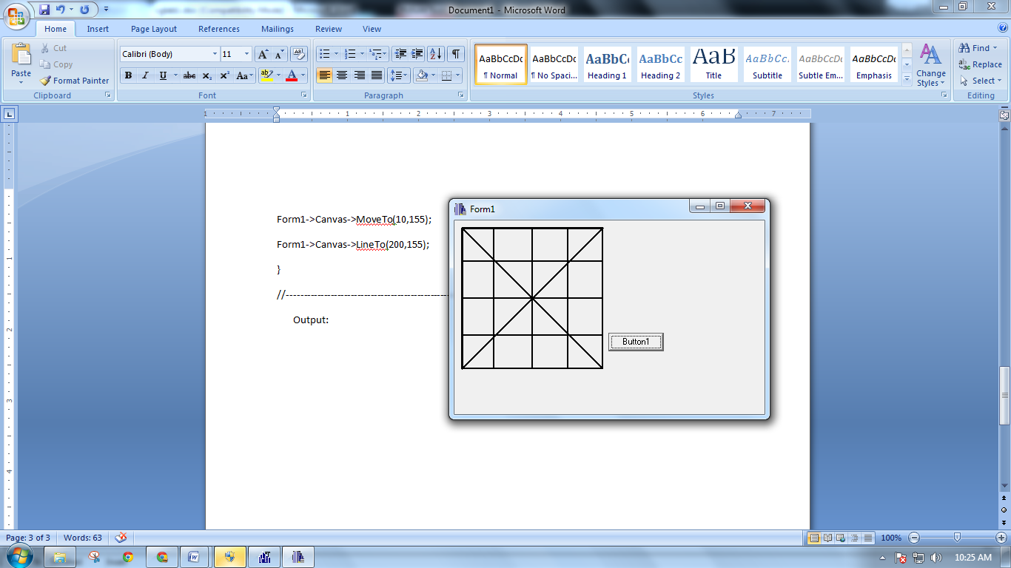

**Conclusion:**

Hence a checkbox can be created using c++ builder.

**Reference :**

http://docwiki.embarcadero.com/RADStudio/XE8/en/C%2B%2BBuilder_Developer's_Guide